**Front-End UI/UX Mini Project**

**1.Title Page**

Project Title: ”My Favorite City Blog.”

* + **Submitted By**:

*Team Members :*

1. *Anna Binoy Augustine : 2462040*

[*anna.binoy@btech.christuniversity.in*](mailto:anna.binoy@btech.christuniversity.in)

1. *Liya Stanly : 2462109*

[*liya.stanly@btech.christuniversity.in*](mailto:liya.stanly@btech.christuniversity.in)

1. *Vyshna Biju : 2462172*

[*vyshna.biju@btech.christuniversity.in*](mailto:vyshna.biju@btech.christuniversity.in)

* + ***Course****: UI/UX Design Fundamentals*
  + ***Instructor Name****: Mr. Narendra*
  + ***Institution****: Christ University*
  + ***Date of Submission****: 26/09/2025*

# 2.Abstract

This project is a responsive, multi-page tourism website titled *Shillong Vibe*, designed to showcase the natural beauty, cultural richness, and attractions of Shillong, Meghalaya. The website is built using **HTML, CSS, Bootstrap, and jQuery** to ensure an engaging user experience across devices.

The design emphasizes a clean, modern aesthetic with typography from *Roboto* and *Playfair Display*, complemented by a palette of soothing colors and subtle animations. The homepage introduces Shillong with a hero section and featured highlights. Dedicated pages present key tourist attractions, cultural insights, a visual gallery, and a contact form integrated with Google Maps for easy navigation.

Interactive elements, such as smooth scrolling, hover effects, fade-in animations, and a sticky navigation bar with dynamic styling on scroll, enhance usability. The contact form provides real-time feedback on submission, while galleries and featured sections offer immersive visual storytelling.

Overall, this website serves as a digital guide to Shillong, combining aesthetic appeal, intuitive navigation, and interactivity to promote tourism and cultural awareness of the “Scotland of the East.”

# 3.Tools & Technologies Used

**-Frontend Languages**

HTML5 → For structuring the web pages and content.

CSS3 → For styling, layouts, colors, typography, responsive design, and animations.

-**Frameworks & Libraries**

Bootstrap 4.5 → For responsive layout, grid system, and styled form elements (used in the contact page).

jQuery → For DOM manipulation, smooth scrolling, fade-in effects, and form handling.

**-Typography & Icons**

Google Fonts (*Roboto*, *Playfair Display*) → For modern and elegant typography.

Font Awesome → For icons and symbols (social icons, UI icons, etc.).

**-Design & Styling**

Custom CSS (style.css) → To define color schemes, navigation bar styling, hero section, cards, galleries, and responsive layouts.

Responsive Media Queries → To adjust the design for mobile, tablet, and desktop devices.

**-External Tools/Integrations**

Google Maps Embed API → To display Shillong’s location in the contact page.

**-Development Tools**

Text Editor/IDE (VS Code, Sublime Text, etc.) → For coding and project management.

Browser Developer Tools (Chrome DevTools, Firefox DevTools) → For debugging, inspecting elements, and testing responsiveness.

# 4.Scope of the Project Tools & Technologies Used

**Scope of the Project:**

The *Shillong Vibe* website serves as a digital guide to promote tourism in Shillong by showcasing its attractions, culture, and scenic beauty. It ensures user-friendly navigation, responsive design, and interactive features such as galleries, animations, and Google Maps integration. The project also allows scope for future enhancements like online booking and event updates.

**Tools & Technologies Used :**

1. **HTML5, CSS3** → Page structure, styling, and responsiveness.
2. **Bootstrap 4.5** → Grid system, responsive layouts, and UI components.
3. **jQuery** → Animations, smooth scrolling, and interactivity.
4. **Google Fonts & Font Awesome** → Typography and icons.
5. **Custom CSS** → Color themes, layouts, and media queries.
6. **Google Maps Embed API** → Location display on contact page.
7. **VS Code & Browser DevTools** → Development and debugging.

5. Tools & Technologies Used

|  |  |
| --- | --- |
| Tool/Technology | Purpose |
| HTML5 | Markup and content structure |
| CSS3 | Styling and layout management |
| VS Code | Code editor |
| Chrome Dev Tools | Testing and debugging |
| jQuery | Animations, smooth scrolling, and interactivity |

# 6.HTML Structure Overview

1. -Used semantic tags: <header>, <nav>, <section>, <footer>.
2. -Sections: **Header, Hero Image, Attractions, Gallery, About Shillong, Contact, Footer**.
3. -Navigation menu built with <ul> and anchor <a> links.
4. -<form> used for the Contact page (name, email, message).
5. -<iframe> used to embed Google Maps.
6. -<img> used for hero banner and gallery images.

# 7.CSS Styling Strategy

* 1. **External Stylesheet (style.css)** used for consistency across all pages.
  2. **Color Scheme**: Soft, nature-inspired palette for a tourism feel (greens, blues, whites).
  3. **Typography**: Google Fonts (*Roboto* for body text, *Playfair Display* for headings).
  4. **Layout**: Bootstrap grid system combined with custom CSS for responsive design.
  5. **Navigation Bar**: Sticky header with hover effects and active link highlighting.
  6. **Hero Section**: Full-width background image with overlay text.
  7. **Cards & Sections**: Rounded corners, subtle box-shadows, and hover transitions.

# 8.Key Features

|  |  |
| --- | --- |
| Features | Description |
| Responsive Design | Works seamlessly on all devices |
| Sticky Navigation Bar | Provides quick access to all sections with smooth scrolling |
| Hero Section | Full-width banner with text overlay for strong first impression. |
| Contact Icons | User-friendly form with fields for name, email, and message |

# 9.Challenges Faced & Solutions

|  |  |
| --- | --- |
| Challenges | Solutions |
| Responsive design issues on mobile and tablet | Used **flexbox**, **CSS grid**, and **media queries** for layout adjustments |
| Contact form interaction | Used **jQuery** to handle form submission dynamically and display success message |
| Fixed header overlapping content | Added **scroll offset** in smooth scroll to prevent overlapping |

# 10.Outcome

* 1. A **multi-page website** with sections: Home, Attractions, Culture, Gallery, and Contact.
  2. A **fixed navigation bar (header)** at the top, with a logo “Shillong Vibe” and links to all pages.
  3. The header **changes color and shadow** when scrolling.
  4. The website uses **Google Fonts** (Roboto and Playfair Display) for modern typography.
  5. **Smooth scrolling** when clicking on internal links.
  6. Sections **fade-in** as you scroll down (using jQuery and CSS classes)

# 11.Future Enhancements

* 1. **Search Bar** – Allow users to quickly search attractions, festivals, or gallery items.
  2. **Language Support** – Add multilingual support (English, Hindi, Khasi).
  3. **Dark Mode Toggle** – Provide light/dark theme switching.
  4. **User Login** – Enable users to sign up and save favorite places.

# 12. Code

**HTML CODES**

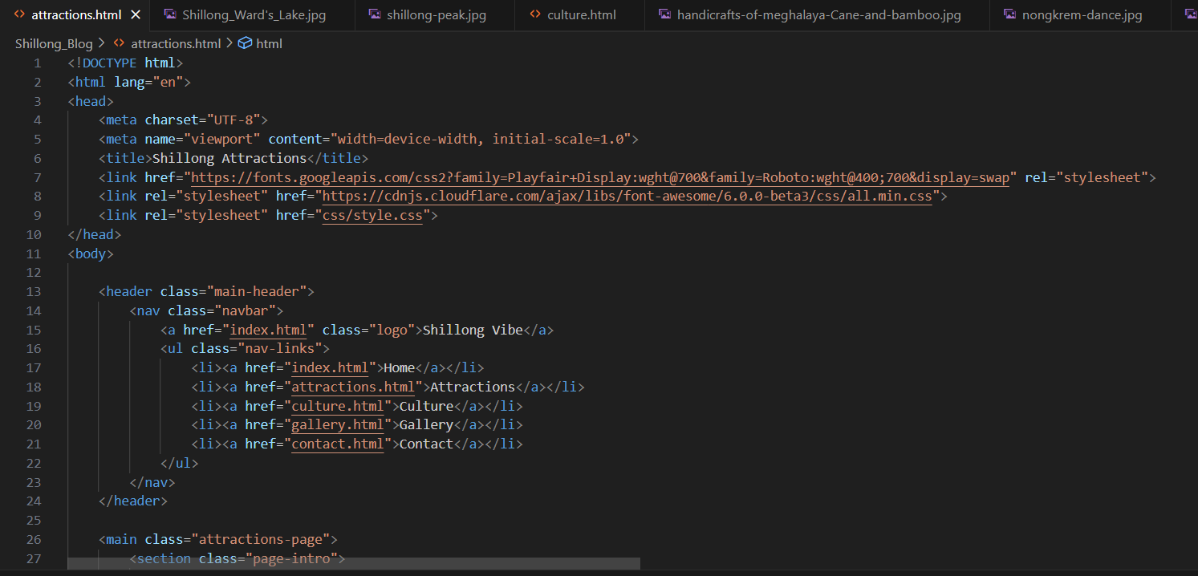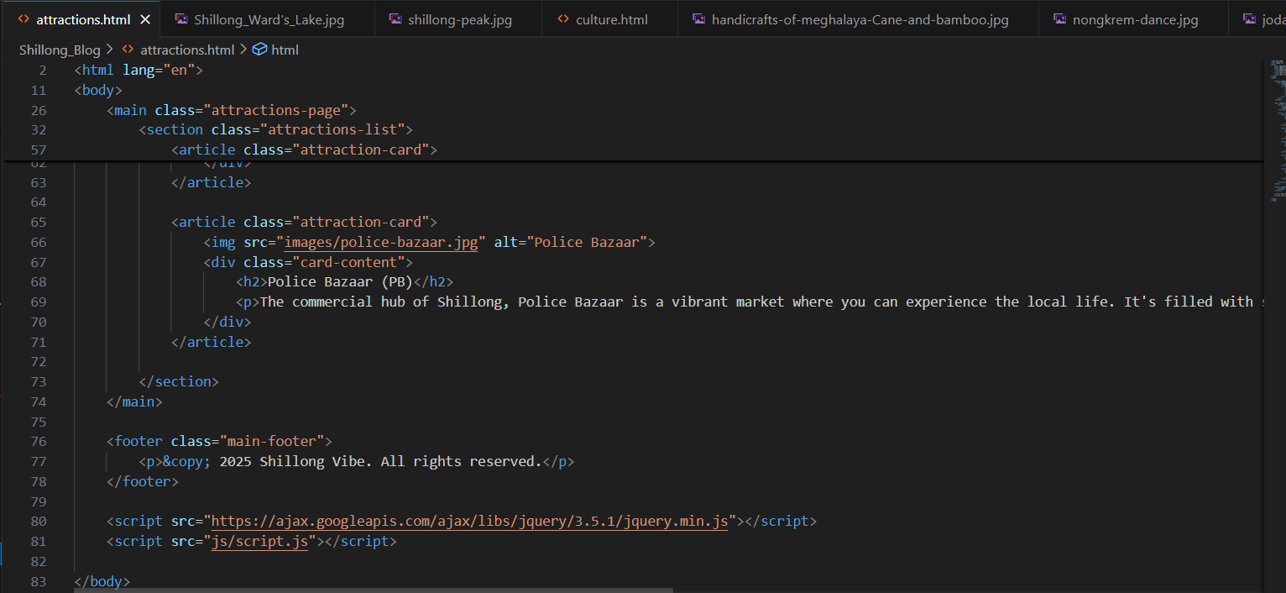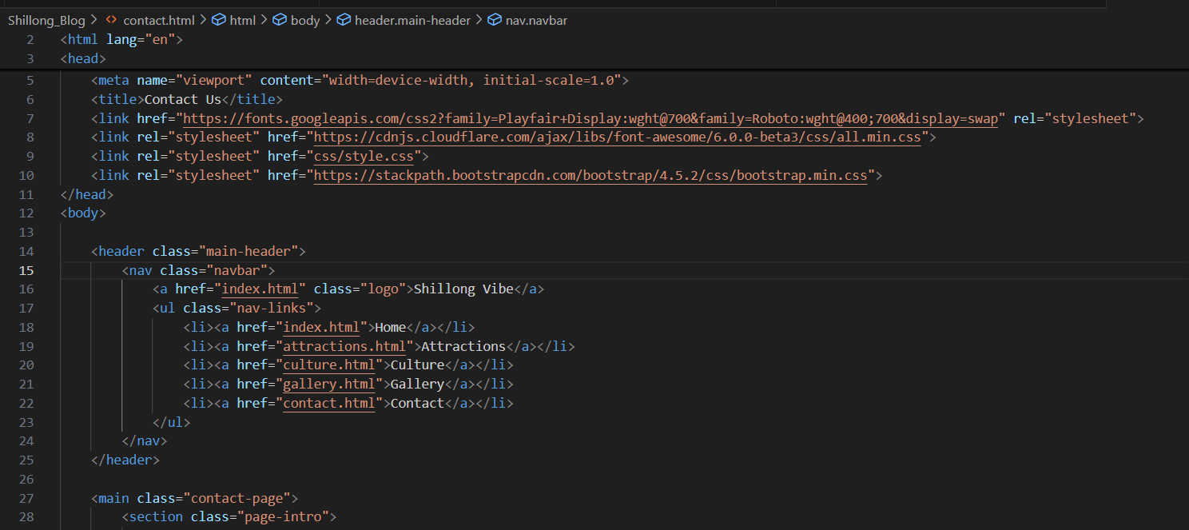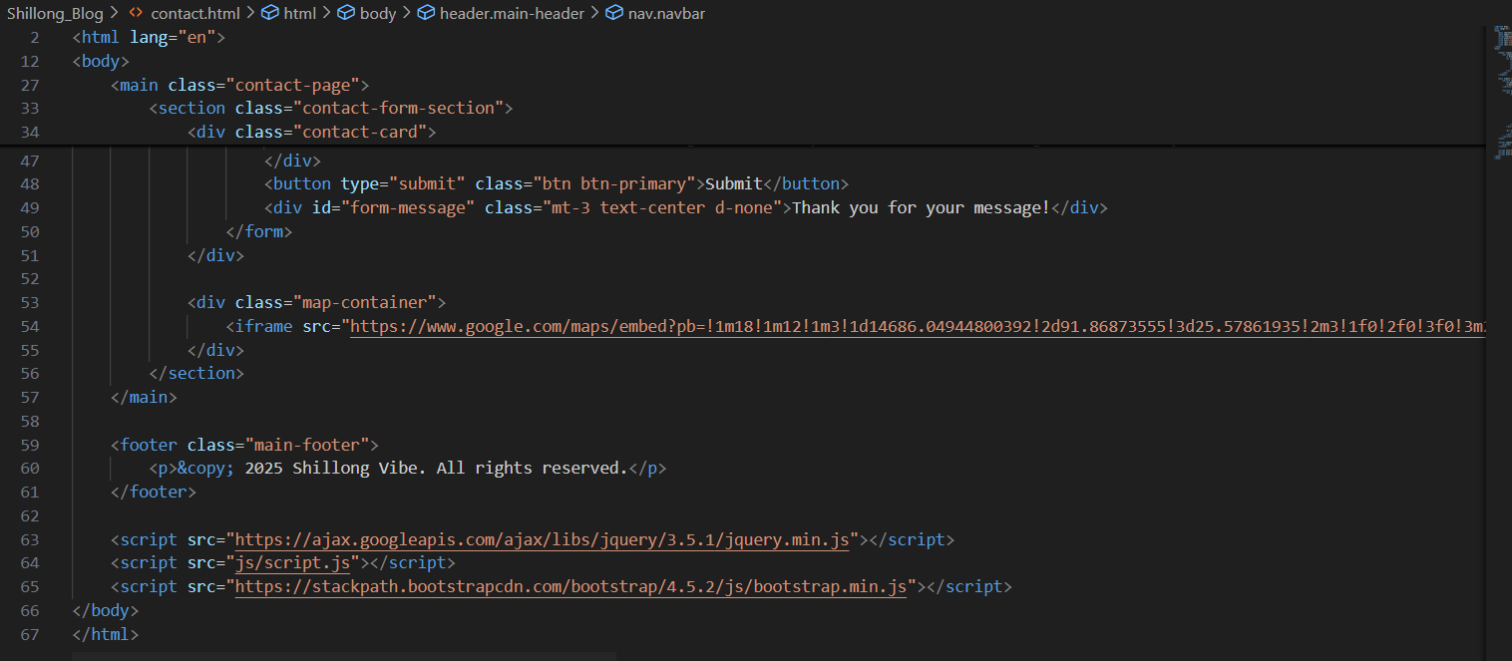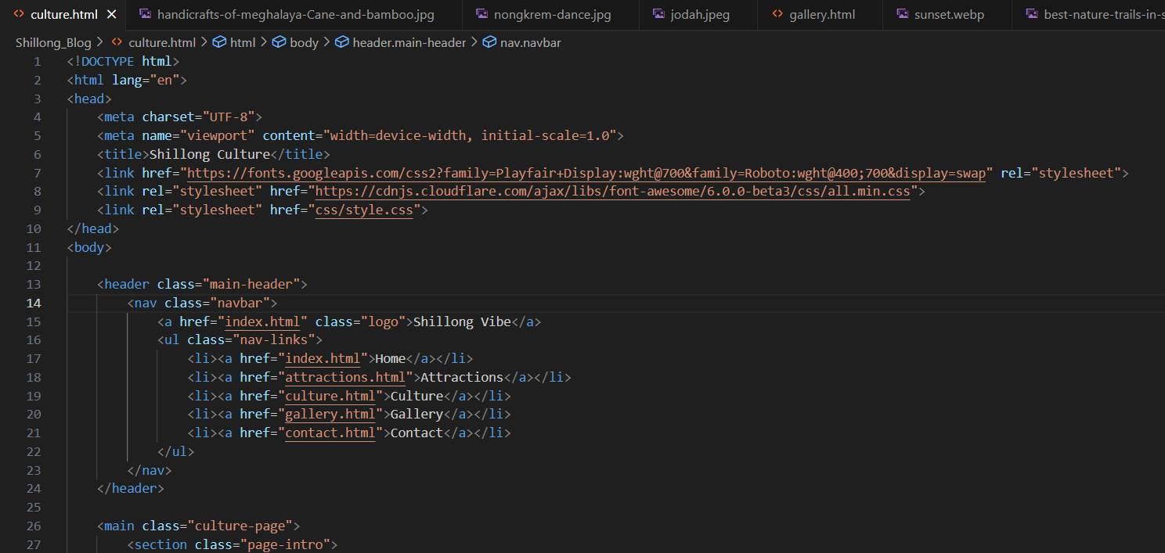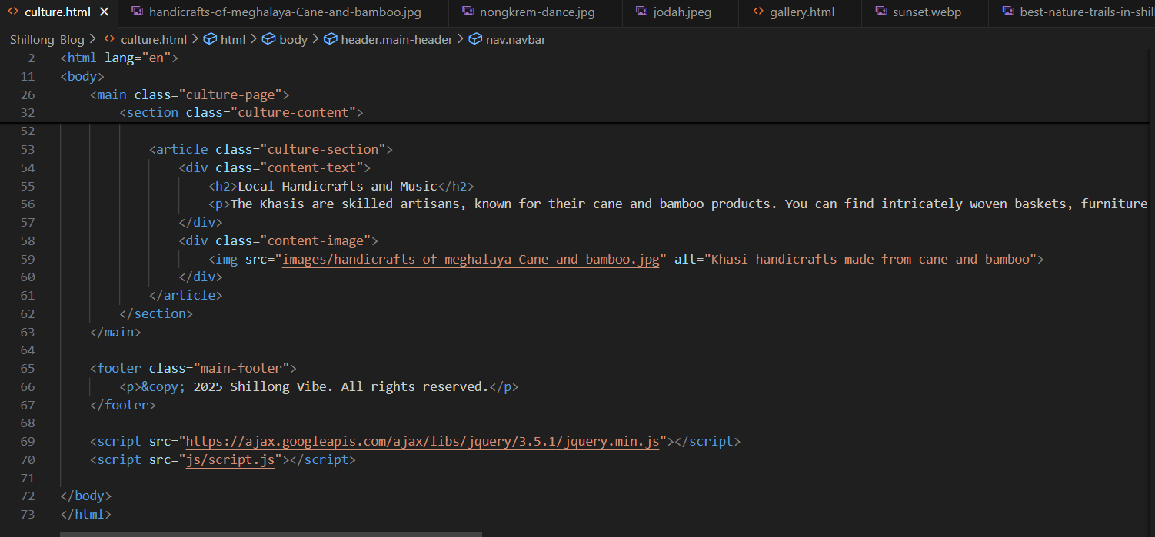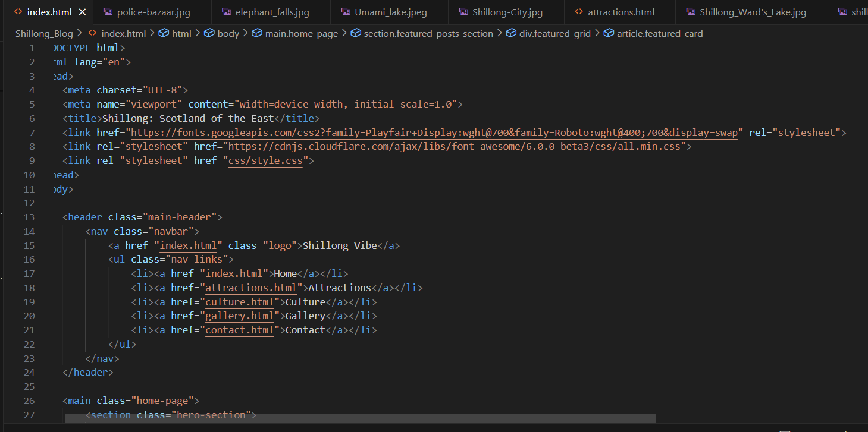

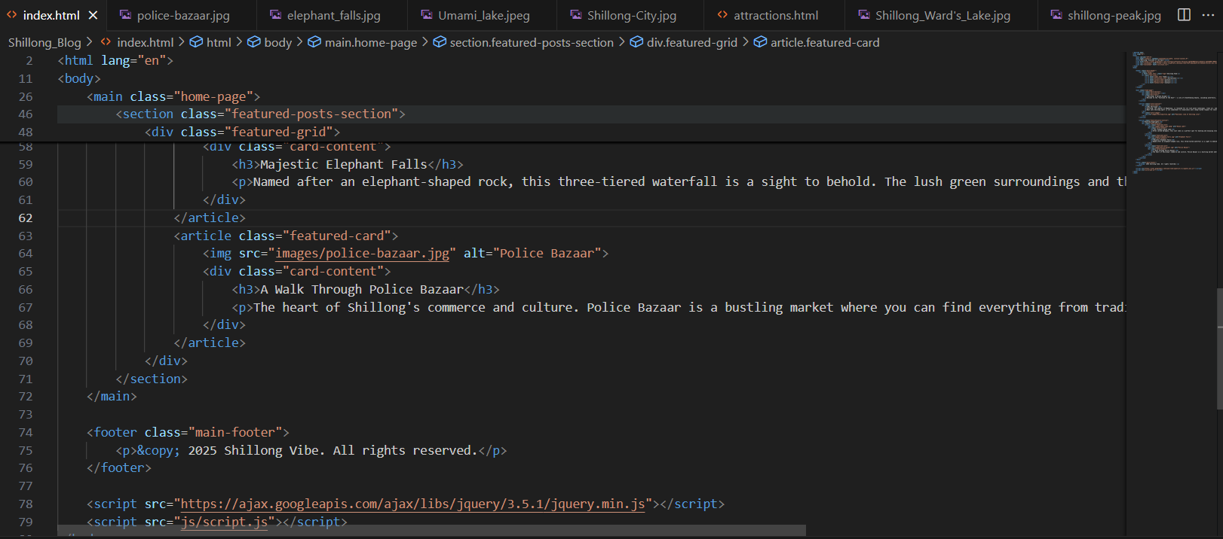

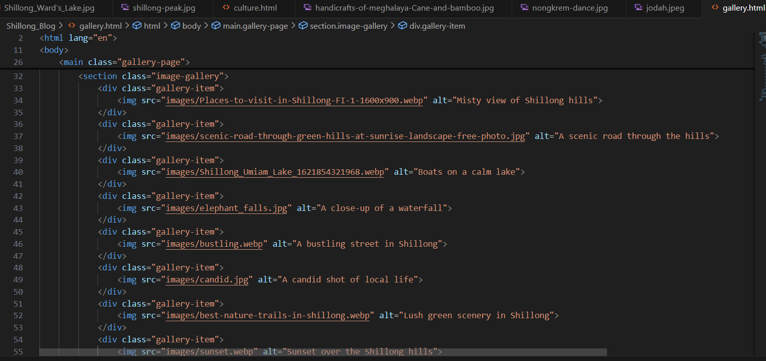

**Bits of CSS Code**

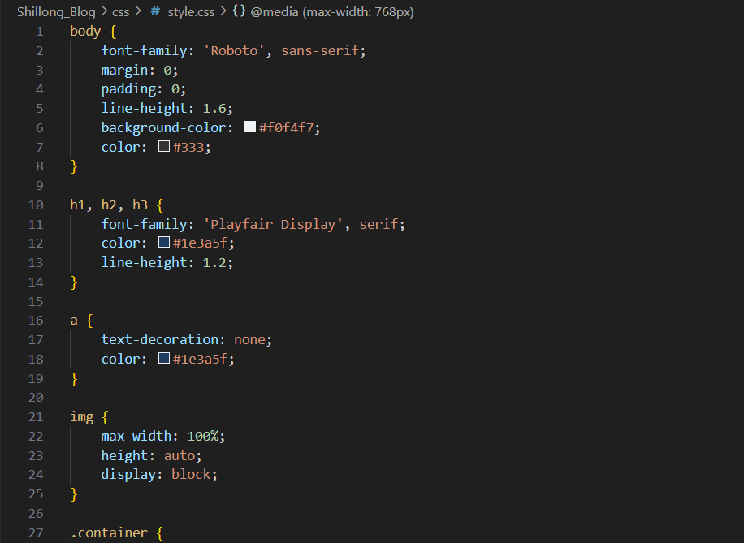

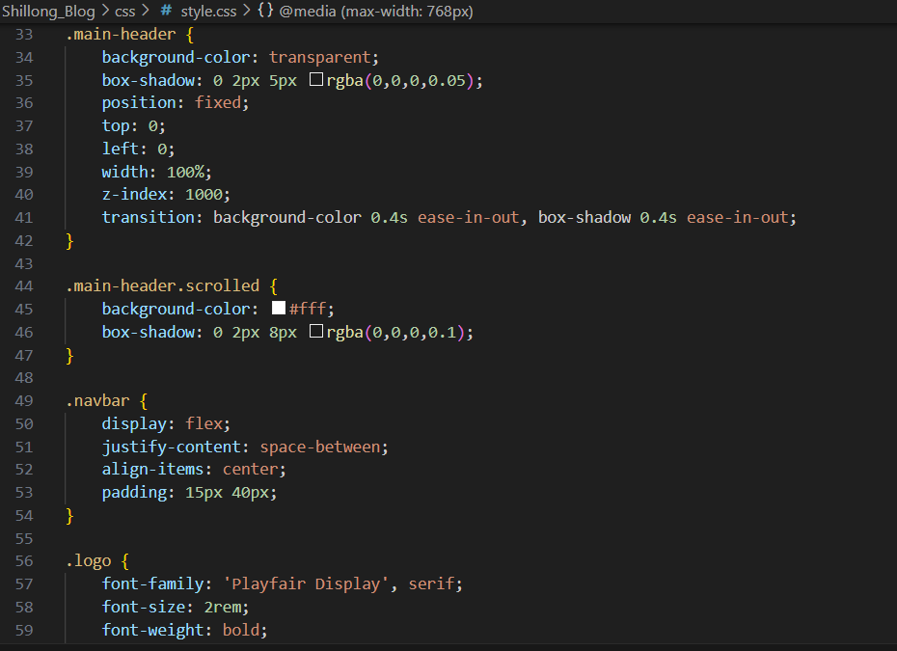

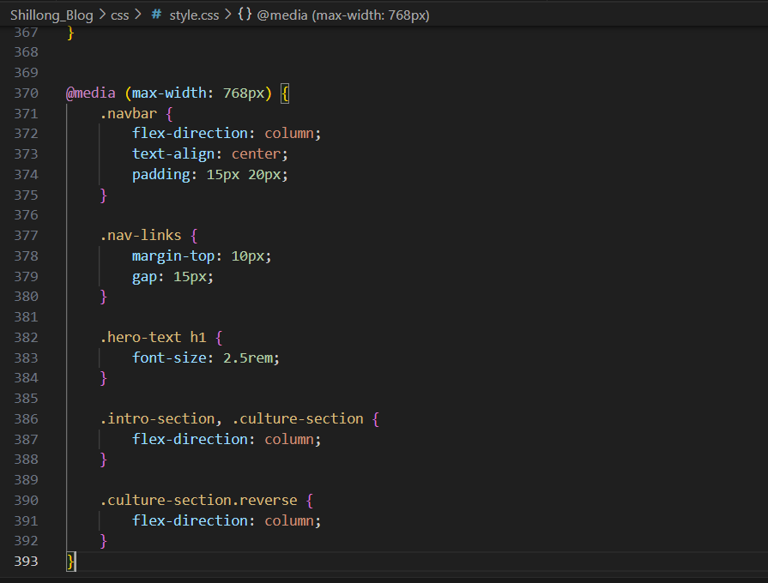

**Js code**

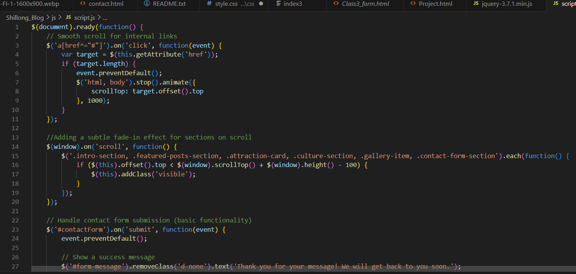

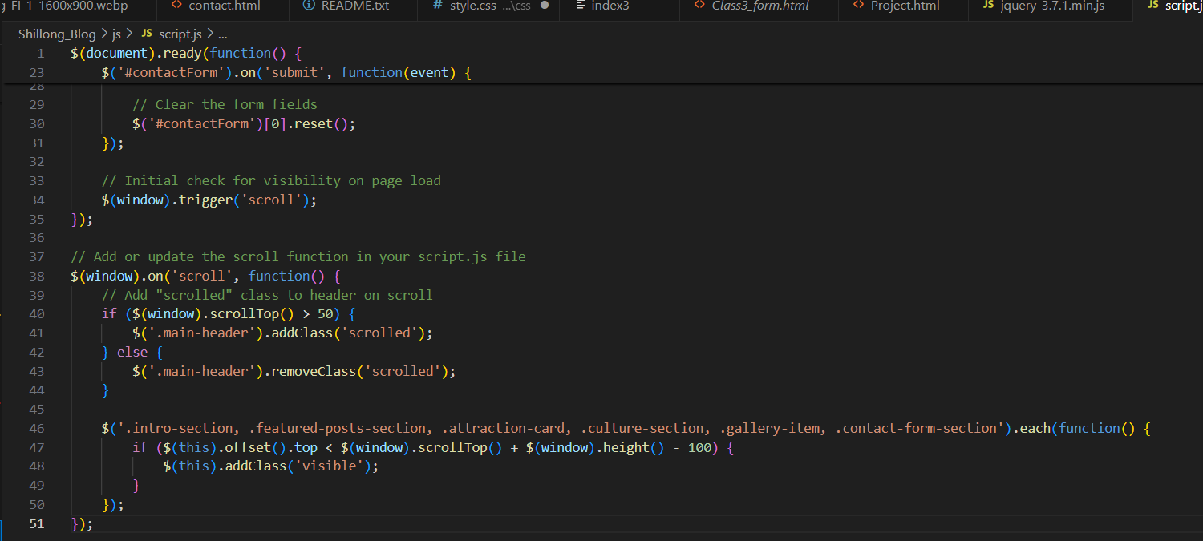

# 13.Screenshot for Final output

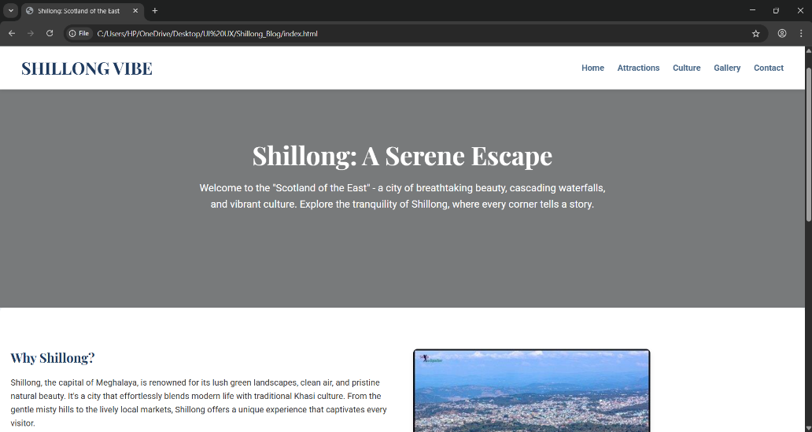

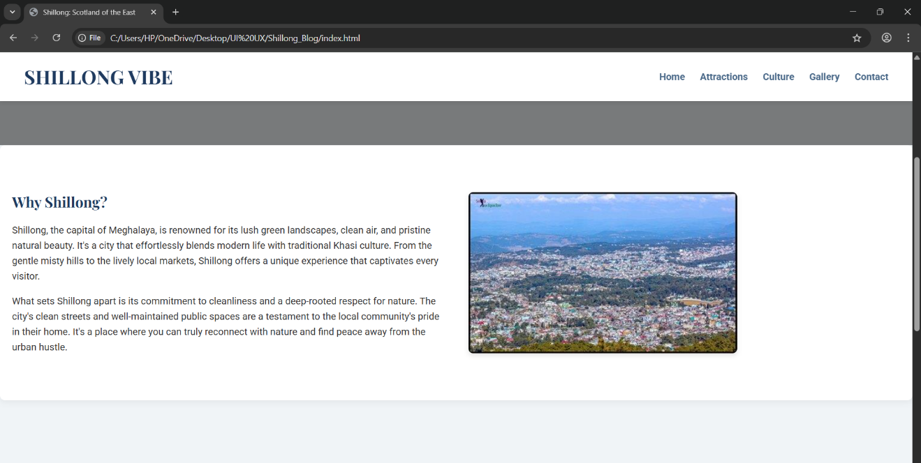

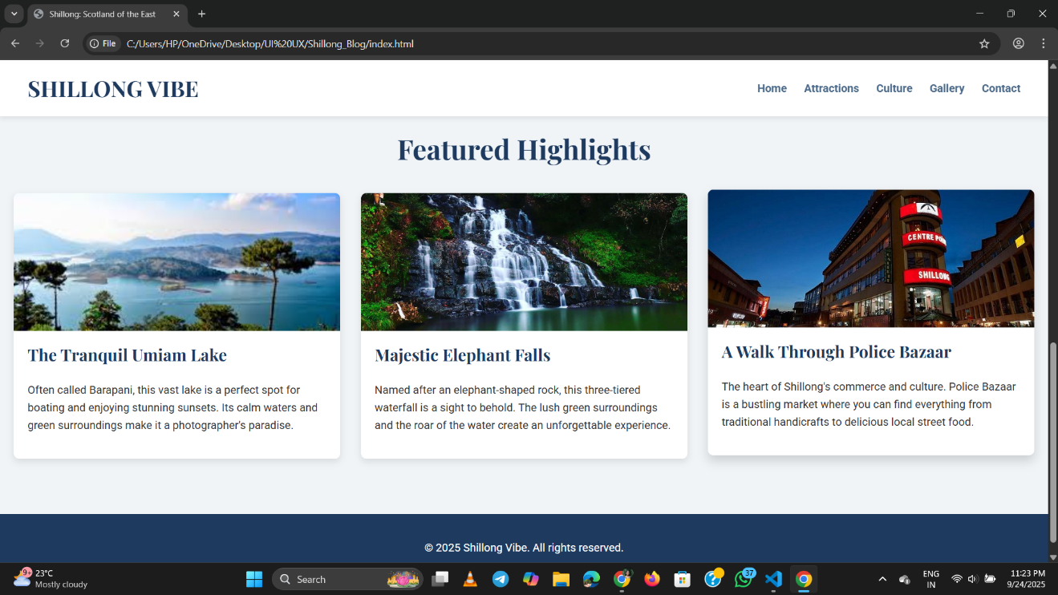

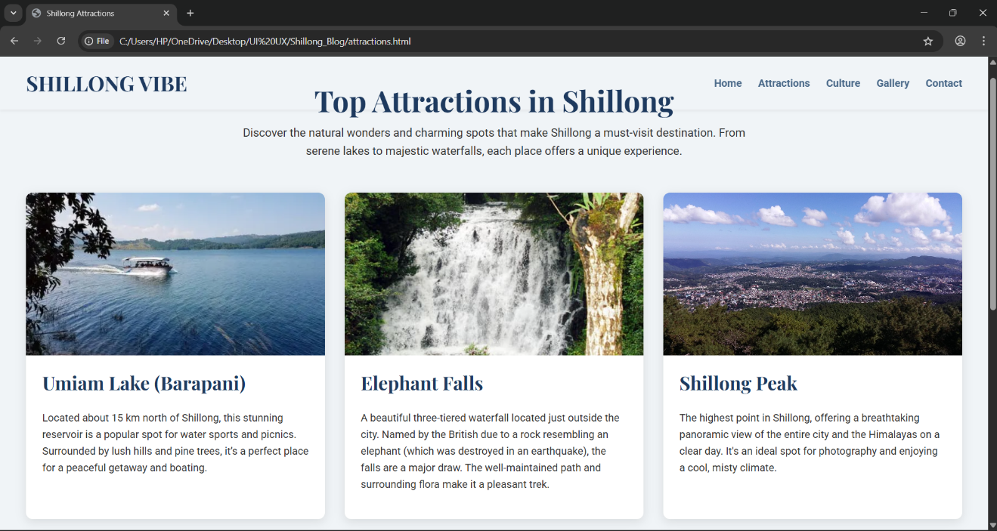

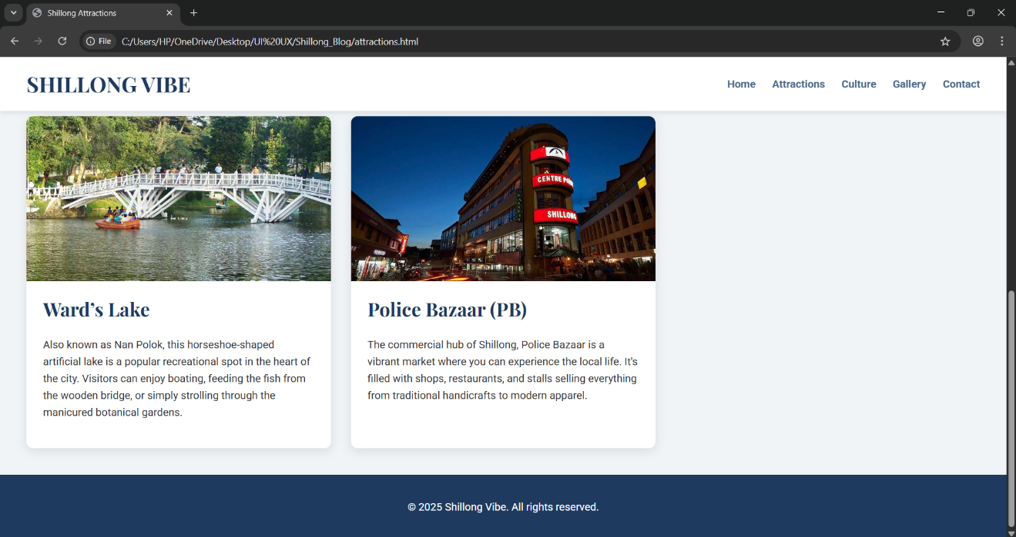

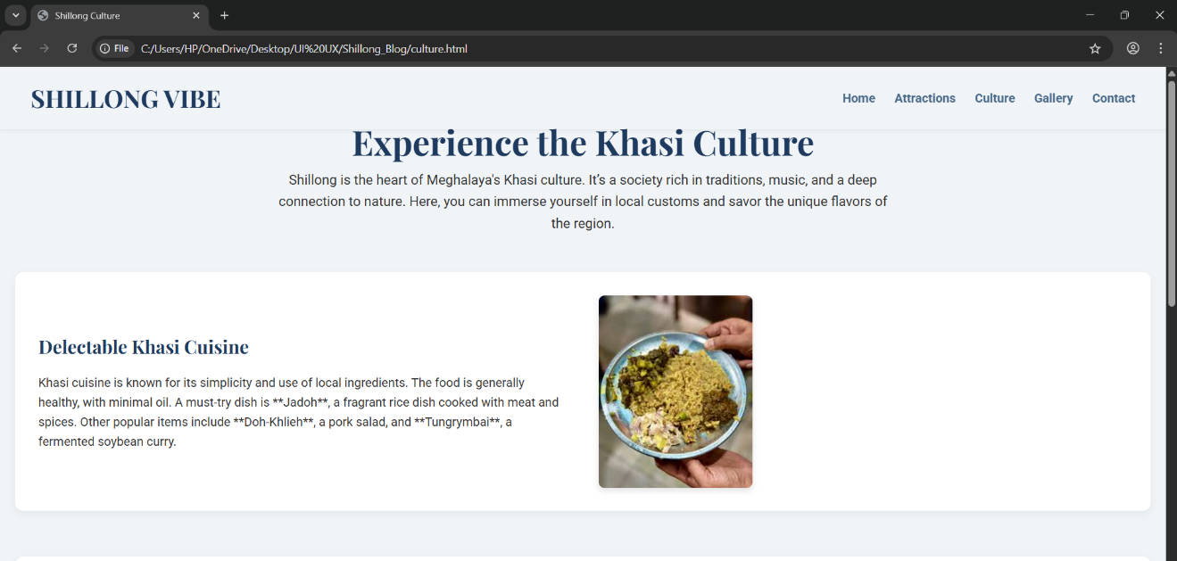

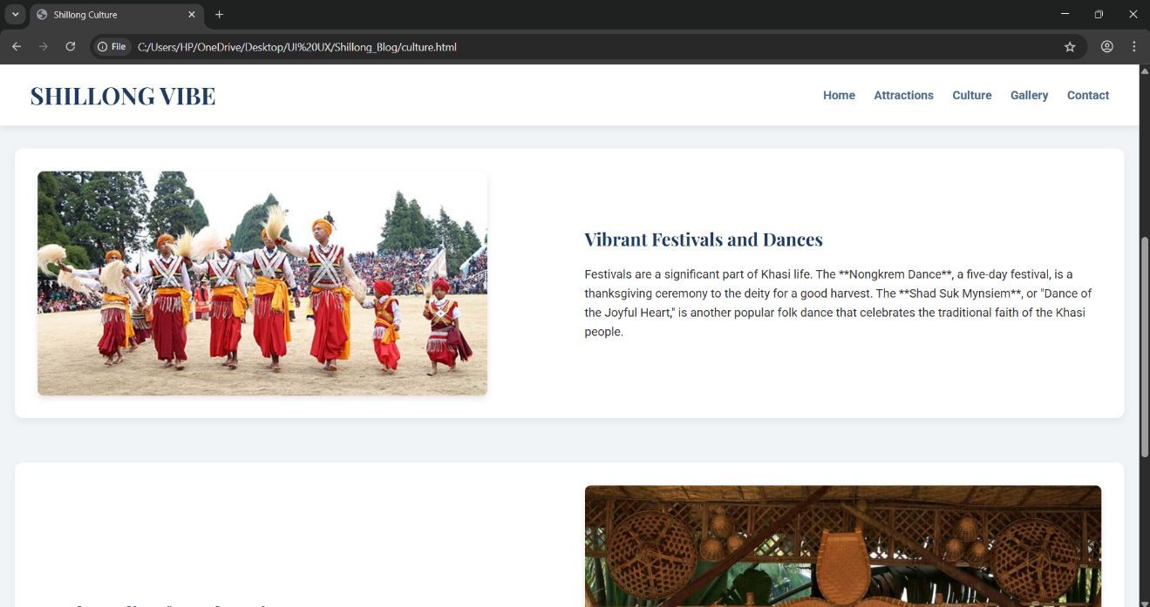

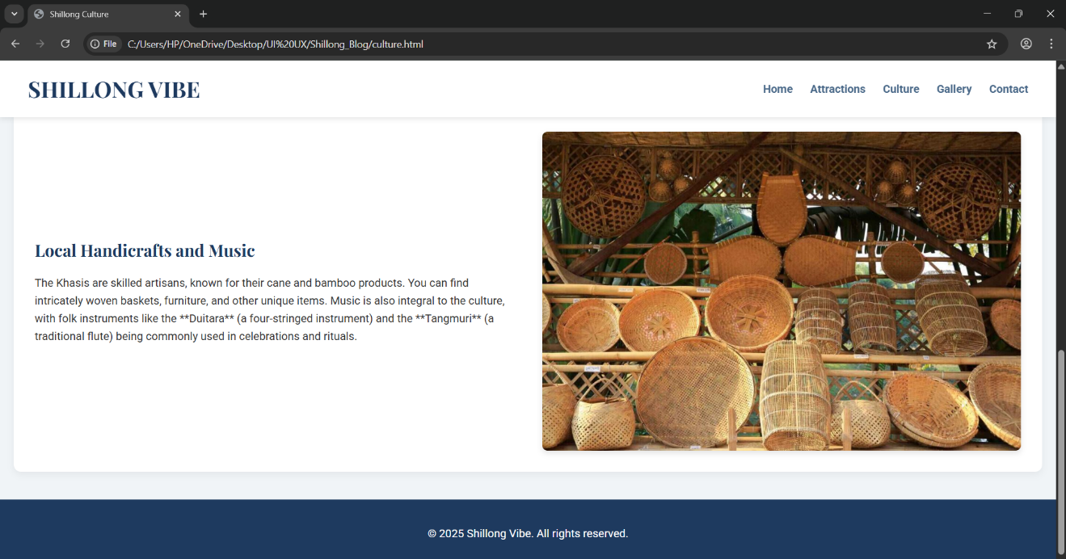

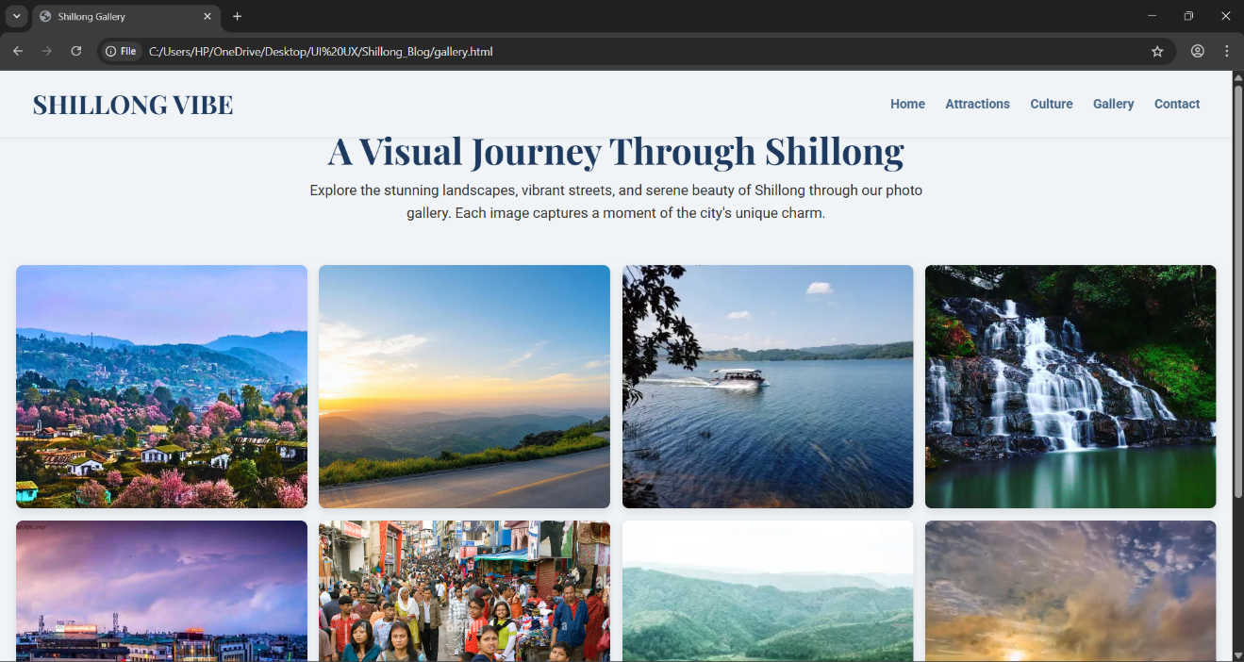

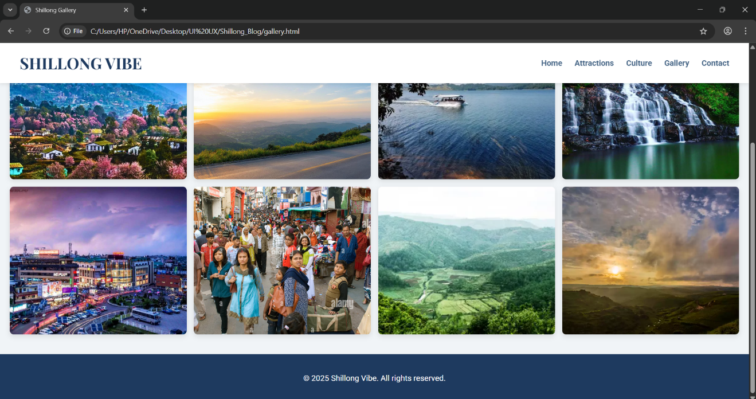

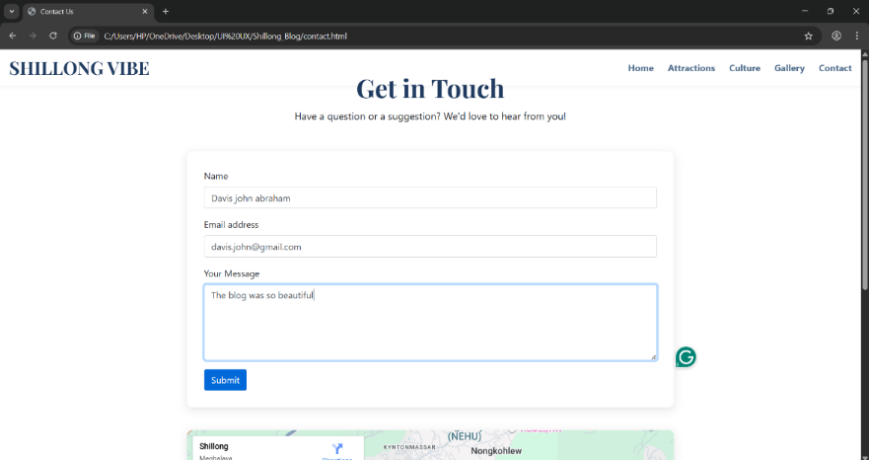

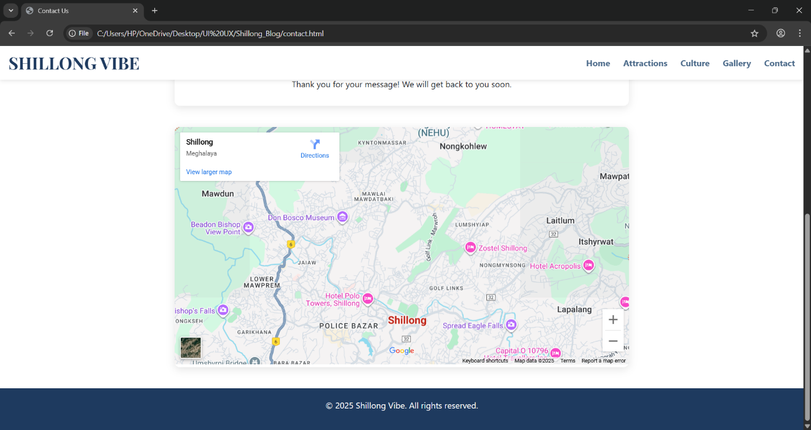

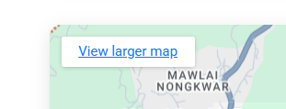

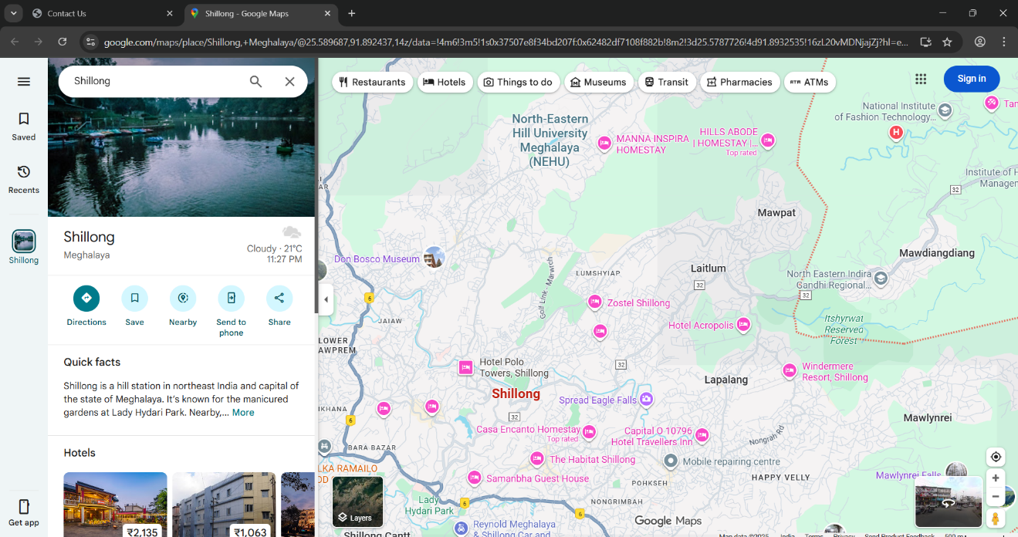



# 14.Conclusion

# This project serves as a **foundation for a tourism-based web platform**, which can be further enhanced with advanced features such as user reviews, event updates, and booking options. It not only highlights the **technical skills in frontend development** but also emphasizes the importance of using technology to promote tourism and culture.

# 15.Reference

***1.*** *W3Schools. HTML, CSS, and JavaScript Tutorial.*

[*https://www.w3schools.com*](https://www.w3schools.com)

***2.****MDN Web Docs. HTML: HyperText Markup Language & CSS Reference. Mozilla.*

[*https://developer.mozilla.org*](https://developer.mozilla.org)

***3.****Incredible India. Shillong Tourism – Meghalaya. Government of India, Ministry of Tourism.*

[*https://www.incredibleindia.org*](https://www.incredibleindia.org)